T he West Bengal State Cooperative bank

How to access Internet banking of the WBSCB Ltd.

First Time User: (Individual)
Step 1: User will receive an Activation message on Mobile phone which is registered at the Bank
Step 2: Enter to the Bank’s URL: https://wbcoopbanks.in/OnlineWBSCB or through
‘Internet Banking’ link in the Bank’s official website: https://www.wbstcb.com
Step 3: Individual Customers are required to Click on New User Registration under Retail User to
generate the Password.

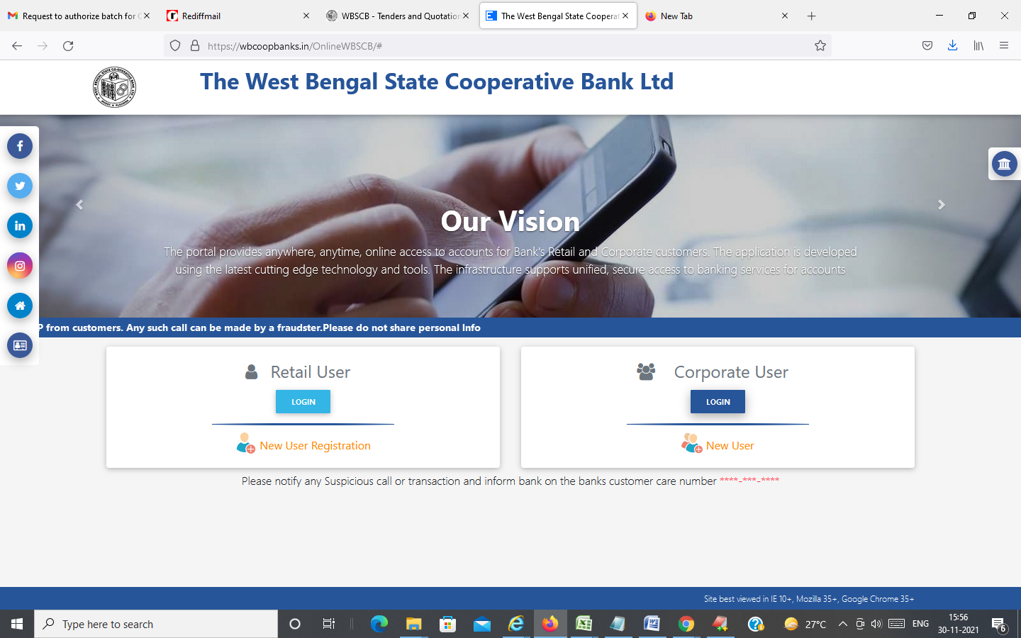

A pop up window will open, Put CIF Number i.e. User ID /User name of your Account and Click on Check button

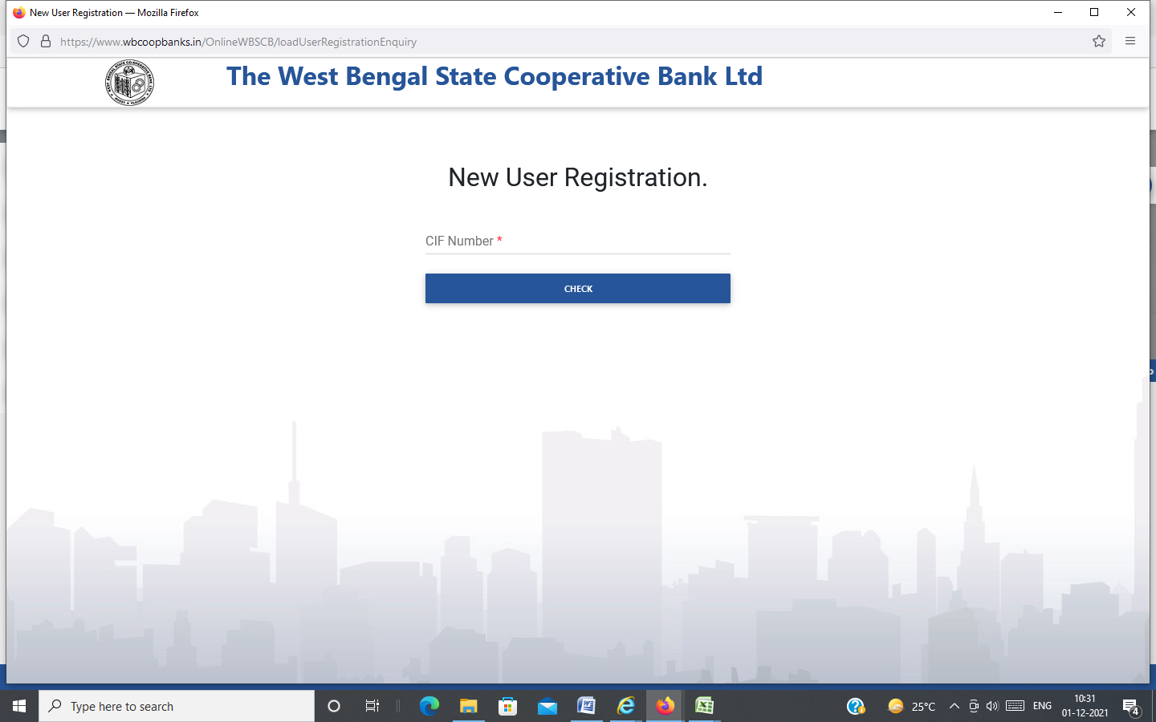

New window will open where the User has to put the Account No., Registered Mobile No., Date of Birth and Captcha shown in the image. Then Tick the Check box below and Click on ‘Submit’ button.

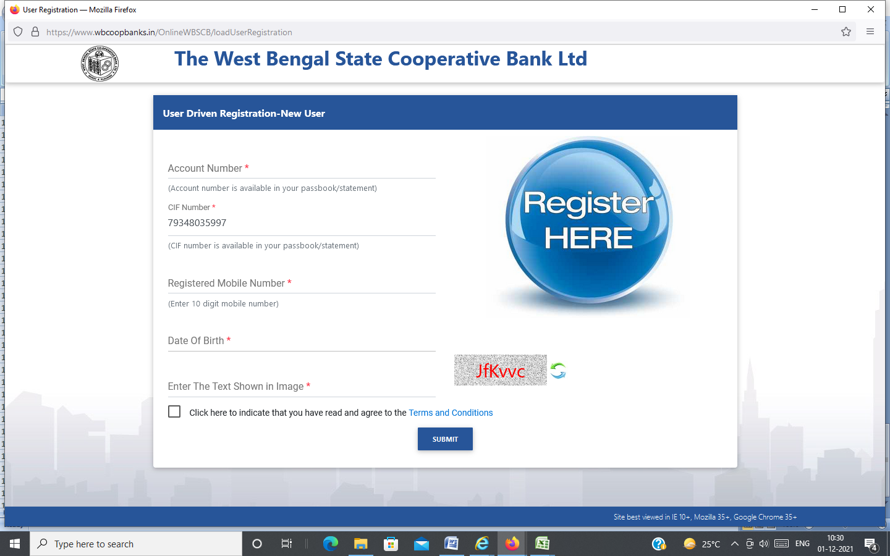

OTP will come in the Registered mobile which you have to put it there followed by clicking on ‘Submit’ button. The password RESET screen will come and the User will do the needful thereon.

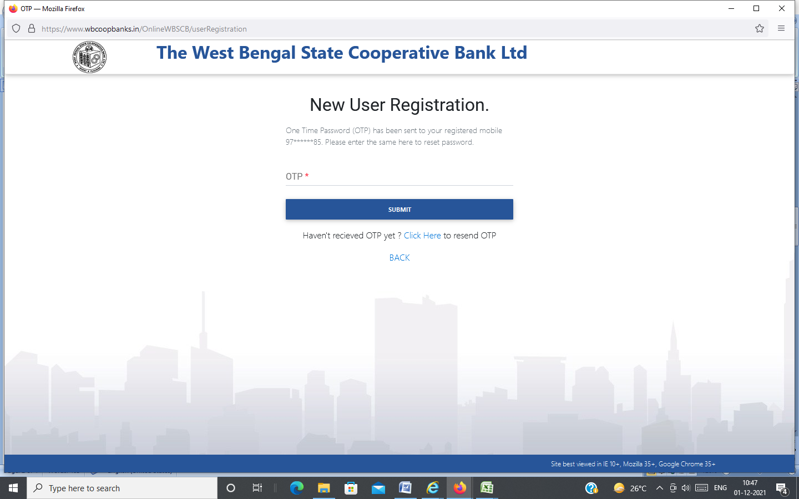

First Time User: (Corporate /Non-Individual)
Step 1: User will receive an OTP on Mobile no. which is registered at the Bank. OTP will remain valid
for 15 days
Step 2: Enter to the Bank’s URL: https://wbcoopbanks.in/OnlineWBSCB or through
‘Internet Banking’ link in the Bank’s official website: https://www.wbstcb.com

Step 3: Non-Individual Customers are required to Click on Login under Corporate User to generate
the Password.

A screen will open, Put CIF Number of your Account both in the fields ‘Corporate ID/CIF’ and ‘Username’. Also put OTP that you received in your registered Mobile and Captcha shown in the image. Then Click on LOGIN button
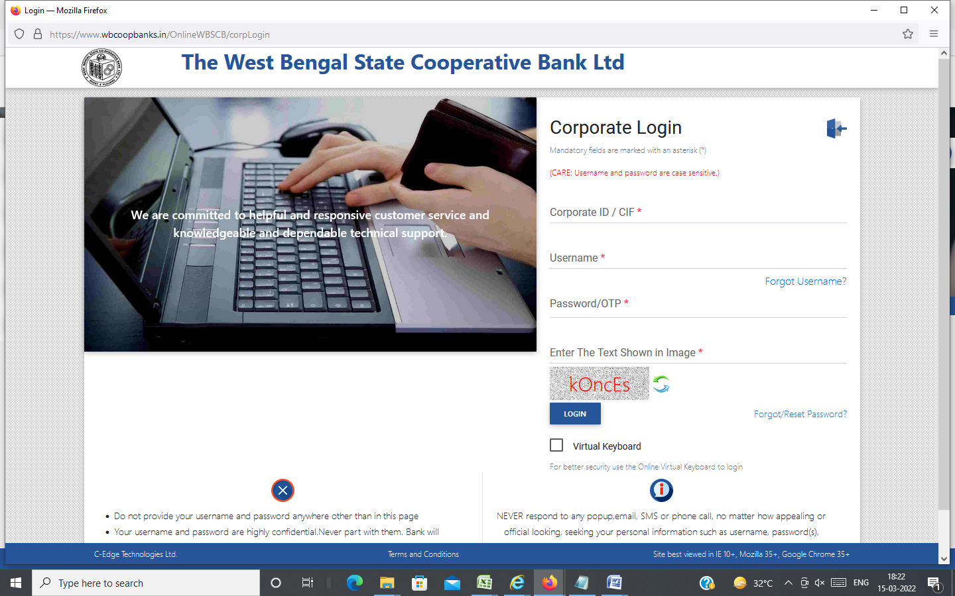

The password RESET screen will come and the User will do the needful thereon.

Existing User: (Individual and Corporate)
Step 1: Clear the ‘History’ of the browser, which the User used previously.
Step 2: Enter to the Bank’s URL: https://wbcoopbanks.in/OnlineWBSCB or through
‘Internet Banking’ link in the Bank’s official website: https://www.wbstcb.com

Step 3: Individual Customers are required to Click on LOGIN under Retail User and
Non-Individual Customers are required to Click on LOGIN under Corporate User

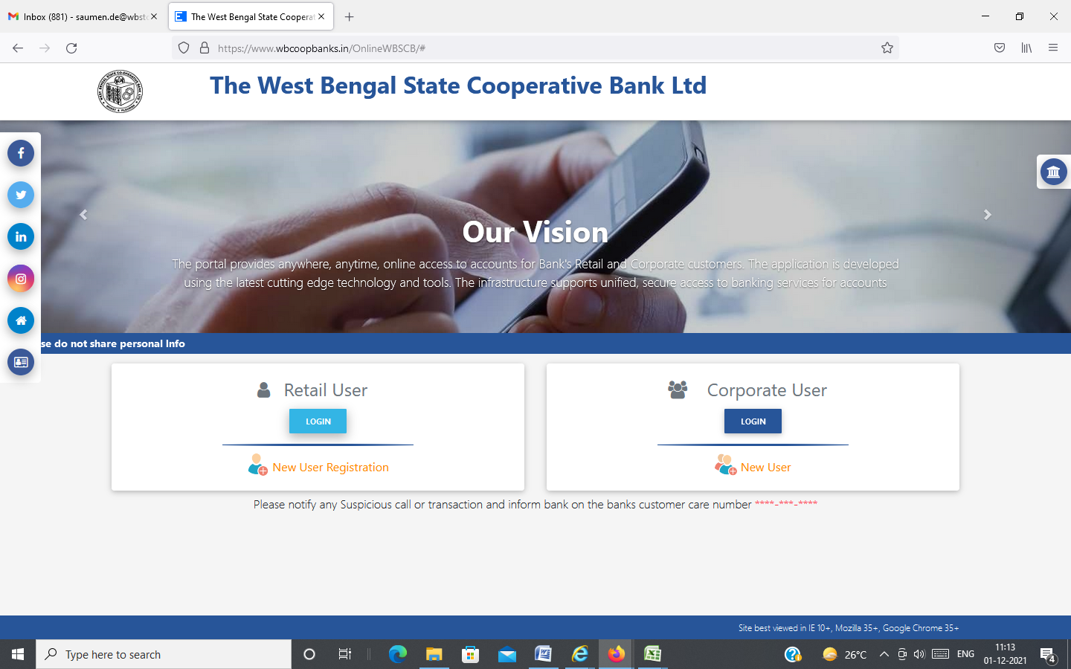

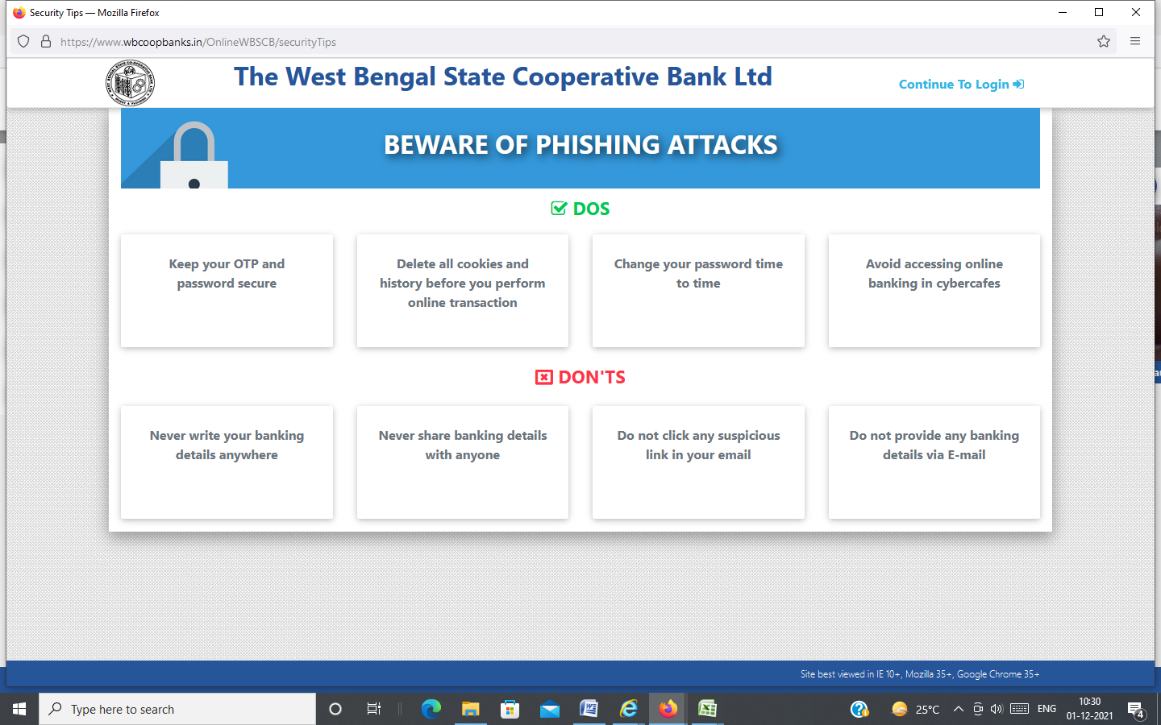

As the passwords of the existing Users have not been migrated, all the Users need to RESET their passwords through ‘Forgot Password’ option as given in the screenshot.

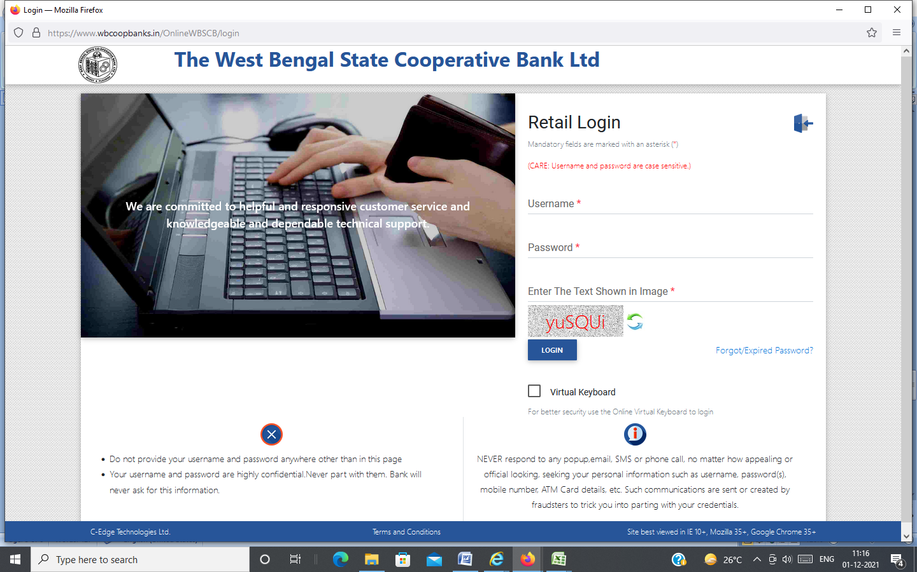

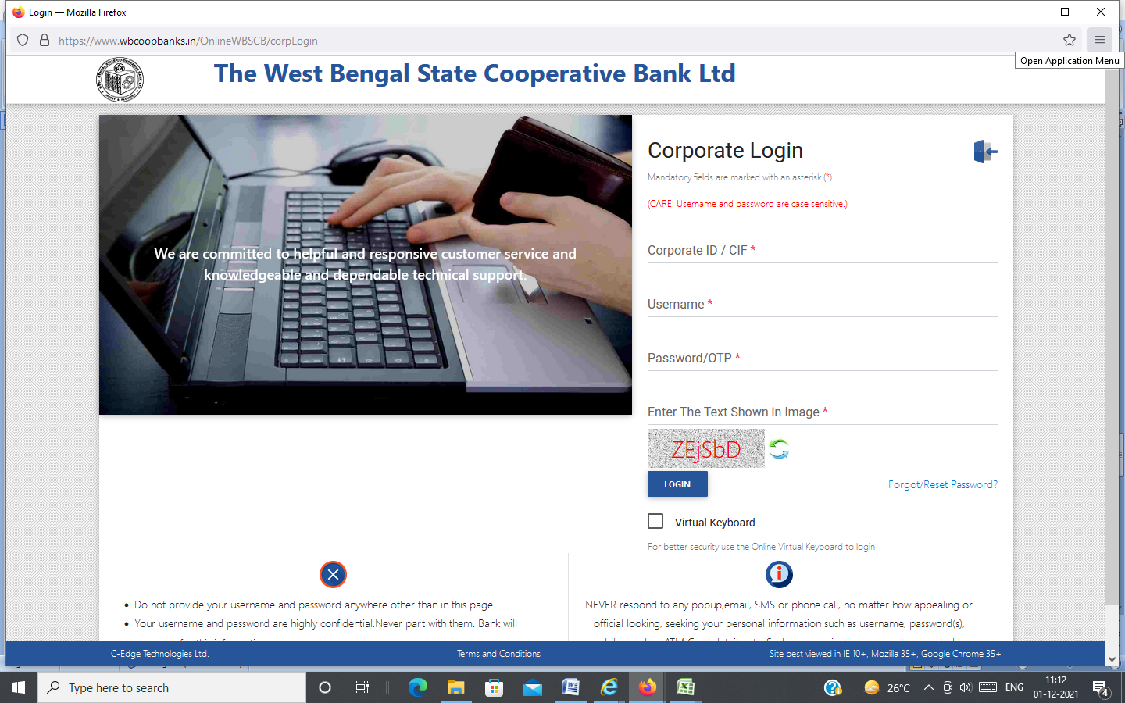

A pop up window will open, Put CIF Number ( i.e. User ID /User name/ Corporate ID) of the account as given by the customer in application form and Click on Submit button.

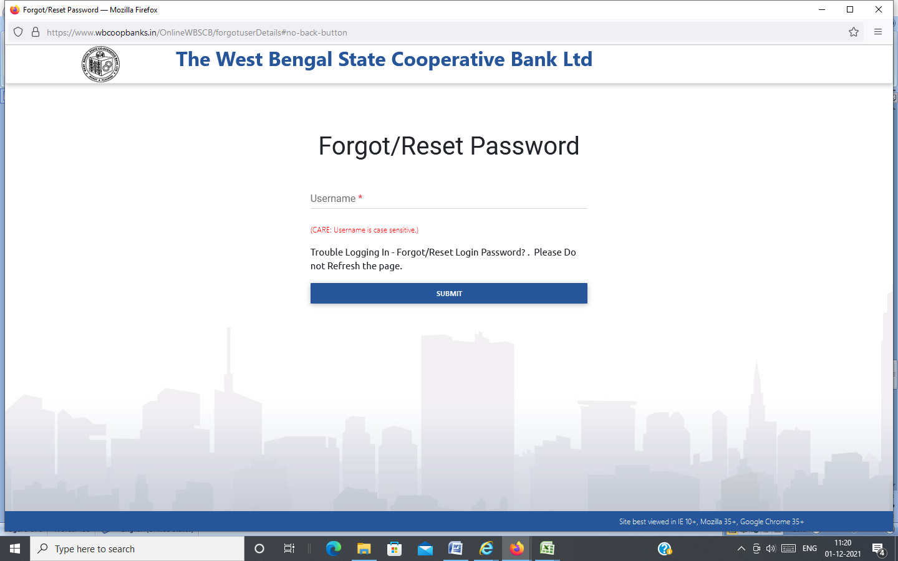

New window will open where the User has to put the User no., Account No., Registered Mobile No., and Captcha shown in the image. Then Click on Submit button. OTP will come in the Registered mobile which the User has to put it there followed by clicking on Submit button. The password RESET screen will come and the User will do the needful thereon.
